DEVOPS FIRST TASK

1. 1. git stash command is used to switch the branch without commiting the current branch.

for exit stash: if you are working on a current project which is not completely done,but you need to make a change so, at this time we have to use this git stash command.

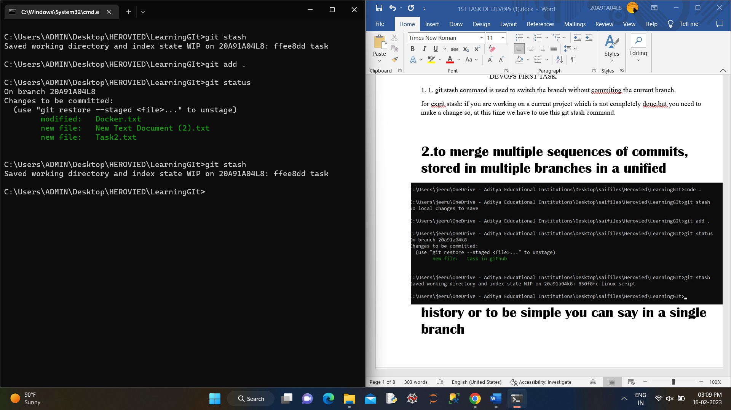2.to merge multiple sequences of commits, stored in multiple branches in a unified history or to be simple you can say in a single branch

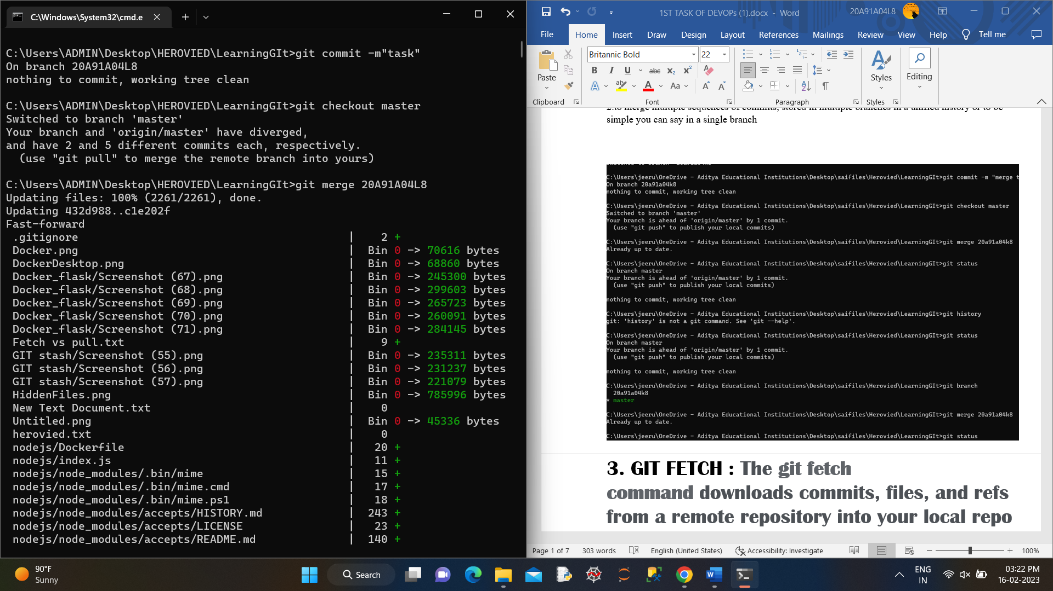

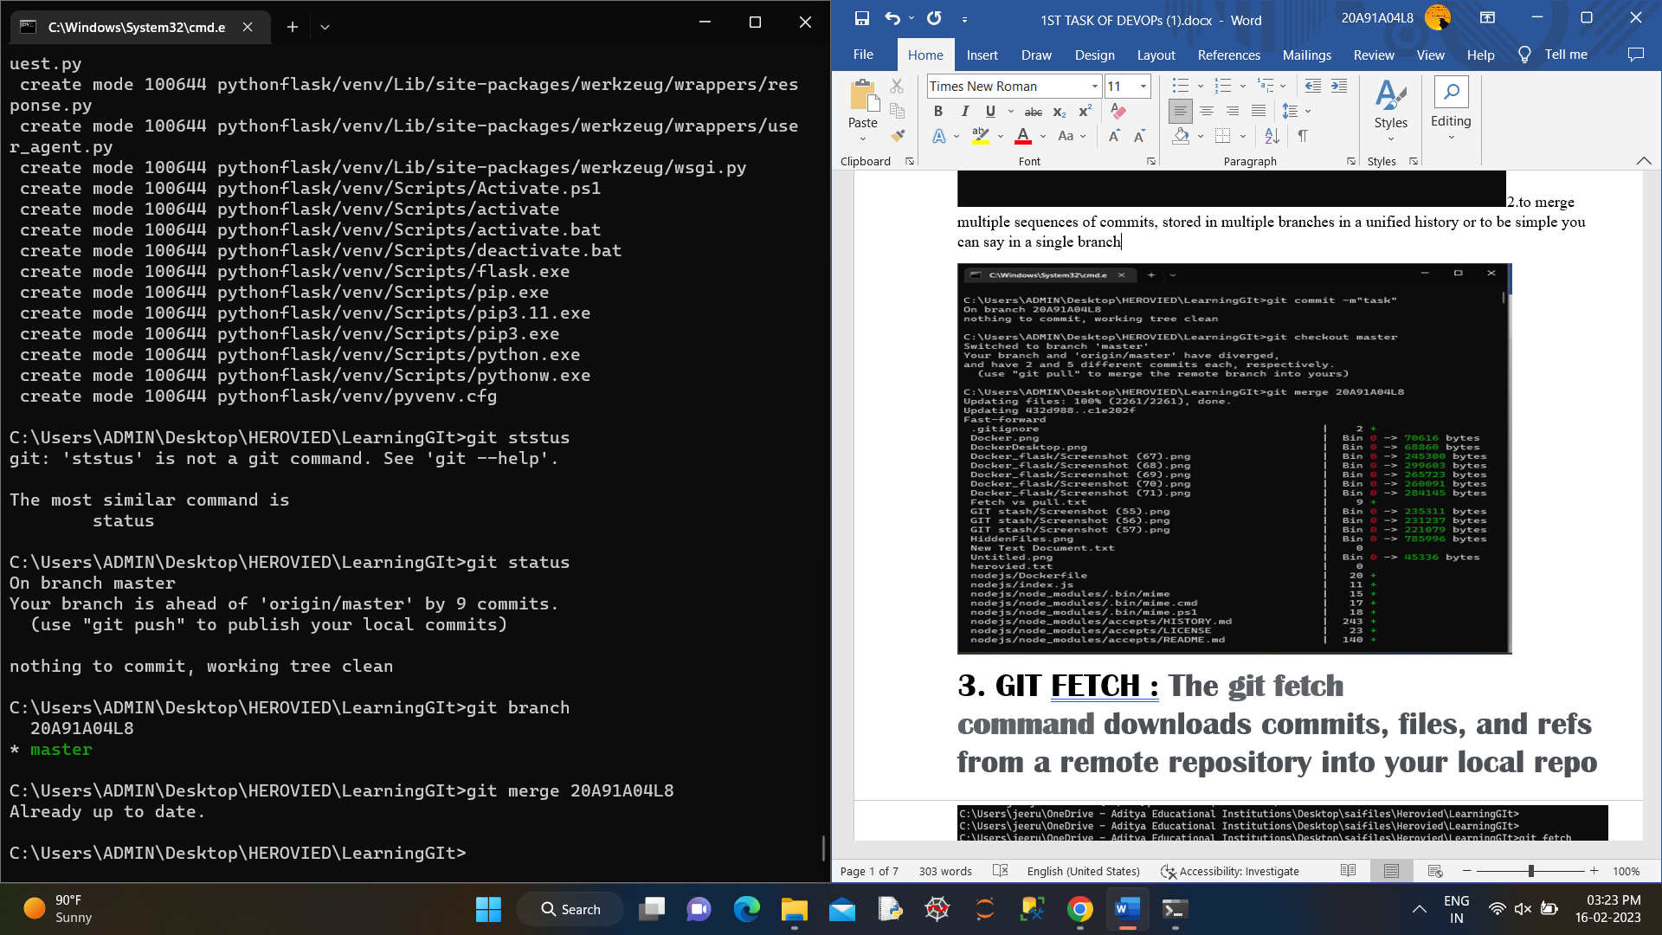

3. GIT FETCH : The **git fetch command** downloads commits, files, and refs from a remote repository into your local repo

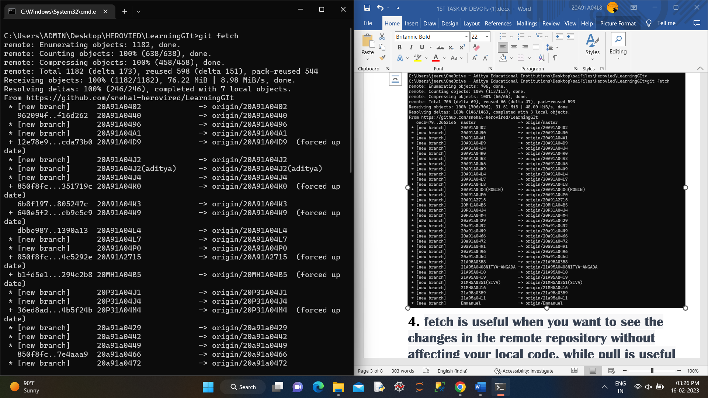

4. fetch is useful when you want to see the changes in the remote repository without affecting your local code, while pull is useful when you want to incorporate changes from the remote repository into your local code.

5.The main operation of AWK is text processing.it reads a text from a file or standard input and processes it based in input and processes it based on the instructions given in the awk program.

AWK can perform a wide range of text processing tasks, including:

1. Searching and replacing text
2. Extracting specific columns from a file
3. Formatting text and output
4. Calculating and summarizing data
5. Filtering data based on conditions

AWK can also use regular expressions and pattern matching to perform complex text processing tasks. It is a powerful tool that is widely used for data analysis, system administration, and other text processing tasks in Linux and other Unix-like operating systems.

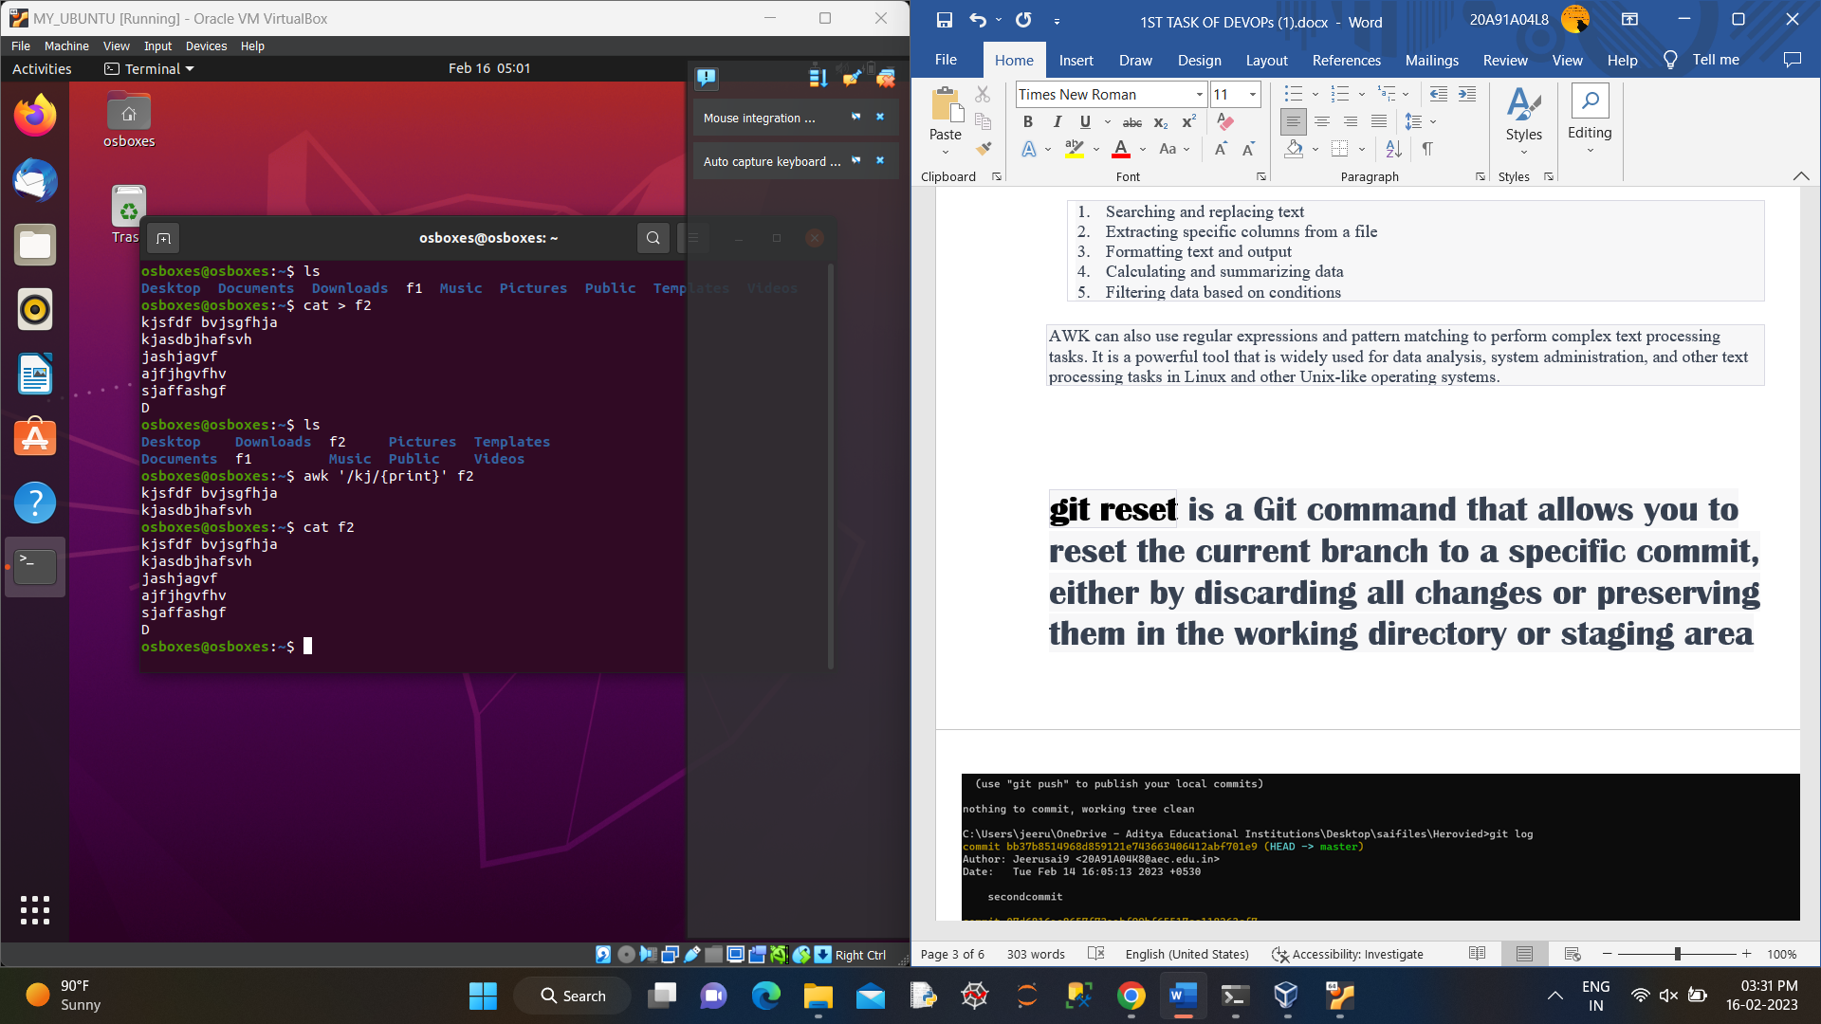

**git reset** is a Git command that allows you to reset the current branch to a specific commit, either by discarding all changes or preserving them in the working directory or staging area

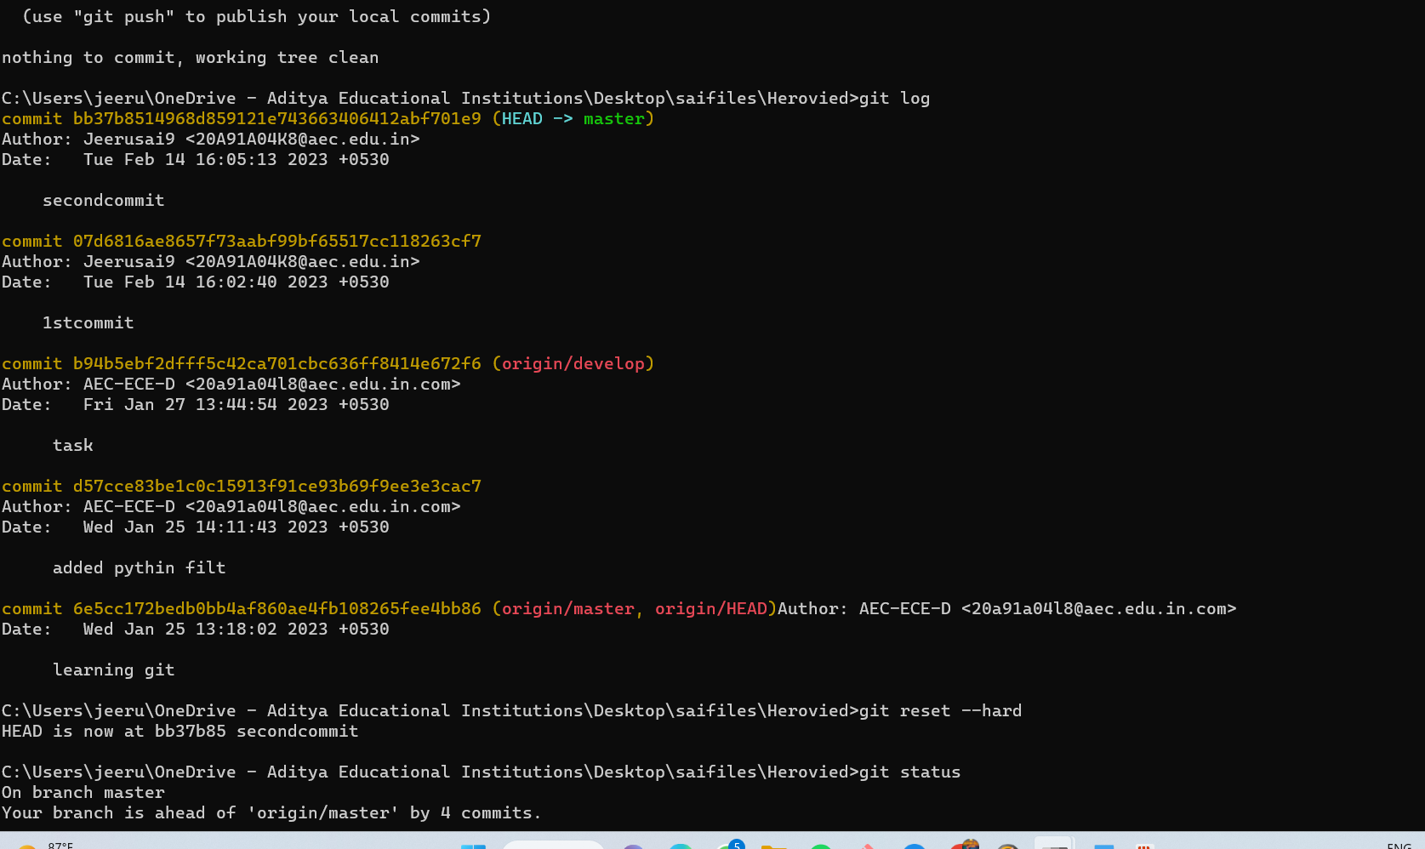

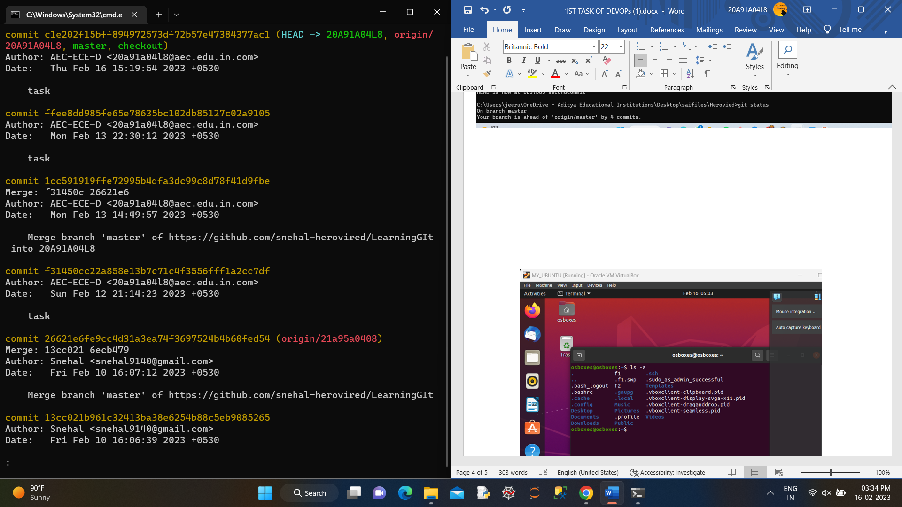

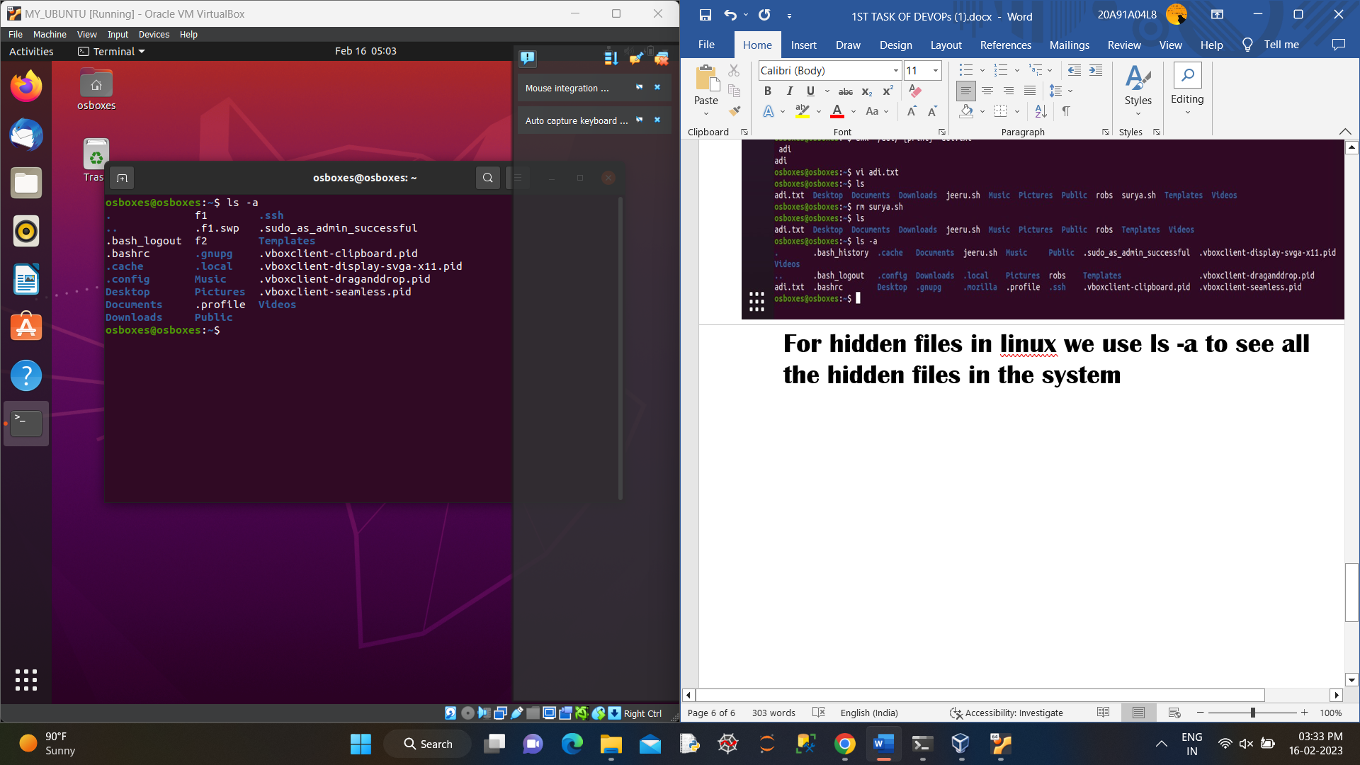

For hidden files in linux we use ls -a to see all the hidden files in the system